Daniel Li 50995133 Cadence

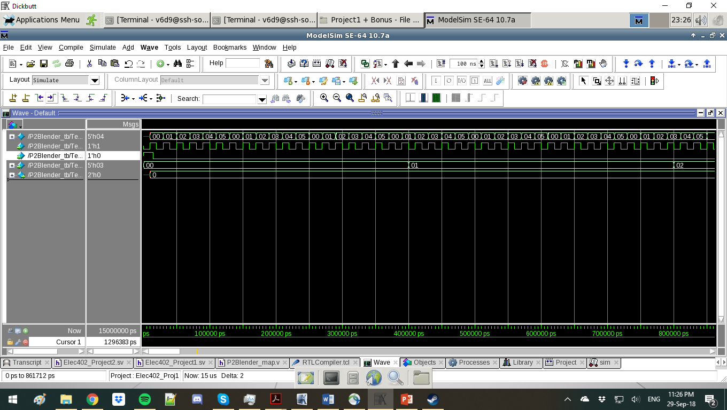

The changing of states for input mode 00, transitions from 00 to 05, which are the null states so output is 00



The changing of states for input mode 01, transitions from 00 to 05, which are the null states so output is 00

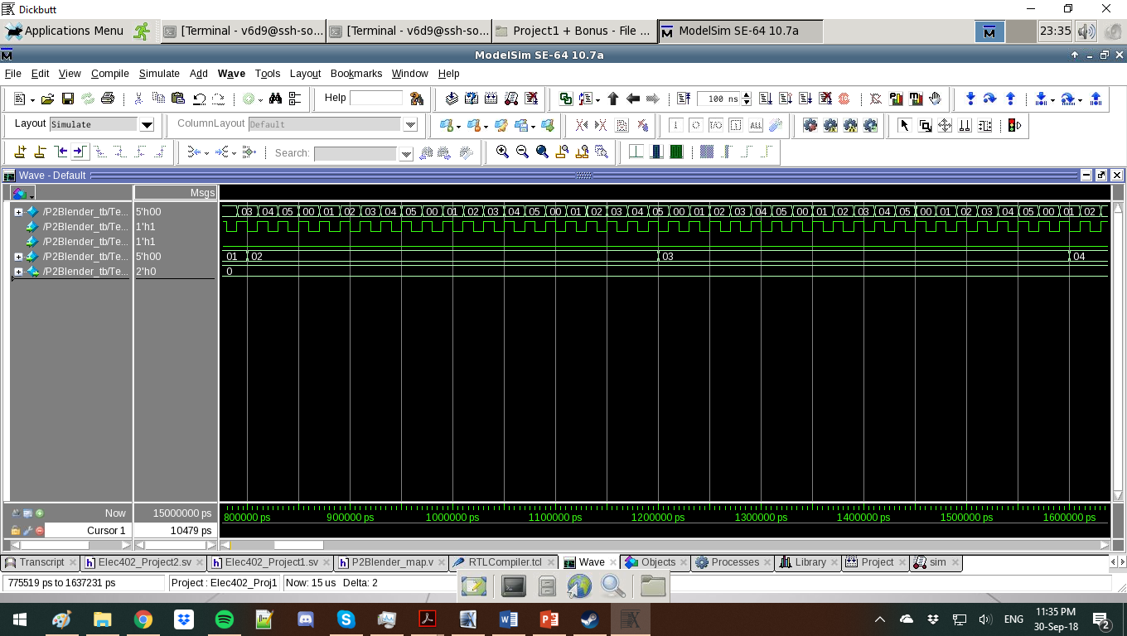

The changing of states for input mode 02, transitions from 00 to 05, which are the null states so output is 00



The changing of states for input mode 03, transitions from 00 to 05, which are the null states so output is 00

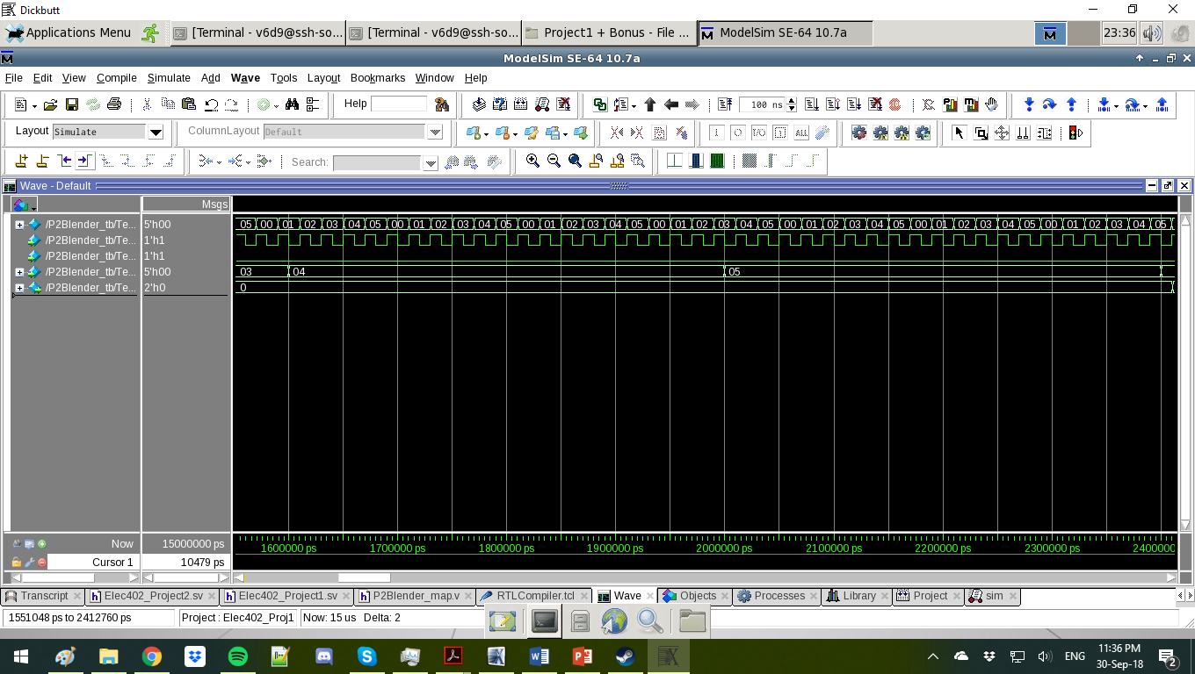

The changing of states for input mode 04, transitions from 00 to 05, which are the null states so output is 00



The changing of states for input mode 05, transitions from 00 to 05, which are the null states so output is 00

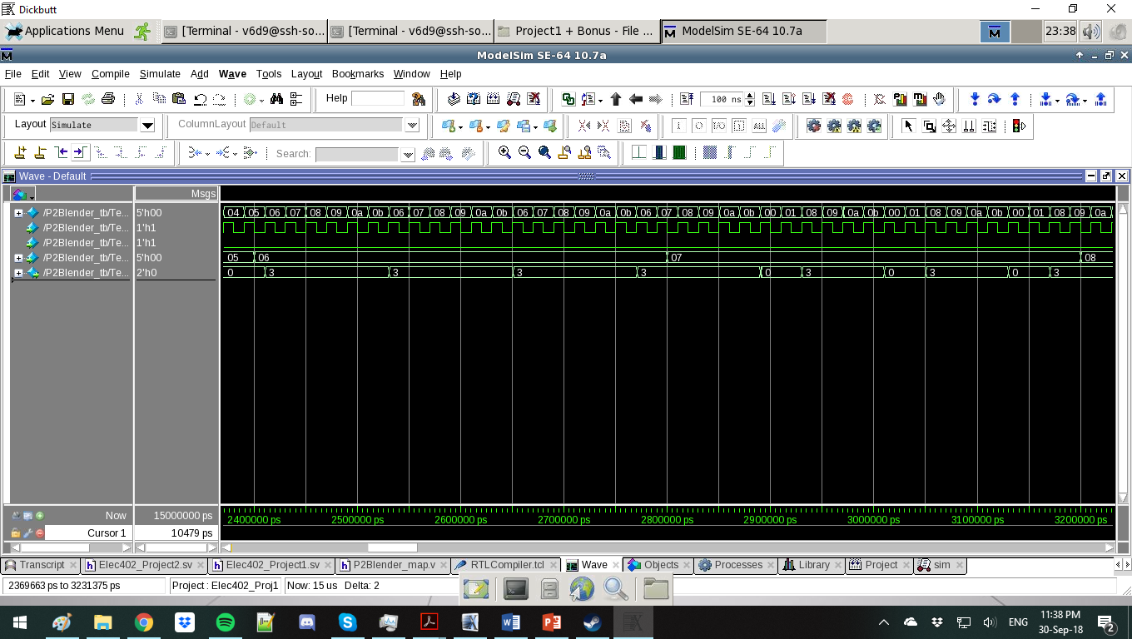

The changing of states for input mode 06, transitions from 06 to 11, which are the high-power states so output is 3



The changing of states for input mode 07, transitions from 06 to 11, which are the high-power states so output is 3

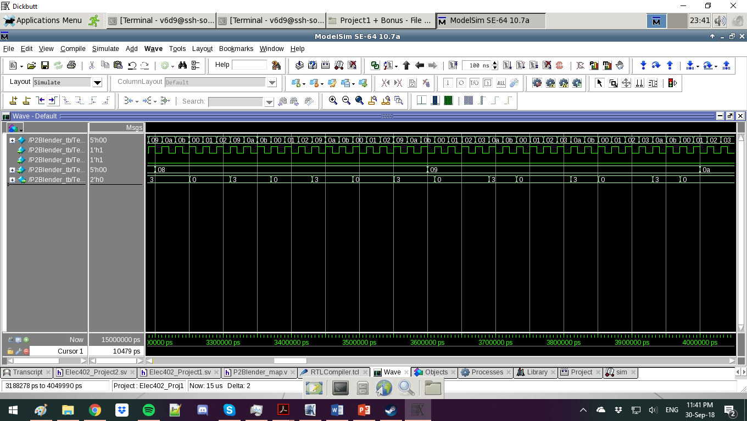

The changing of states for input mode 08, transitions from 06 to 11, which are the high-power states so output is 3



The changing of states for input mode 09, transitions from 06 to 11, which are the high-power states so output is 3

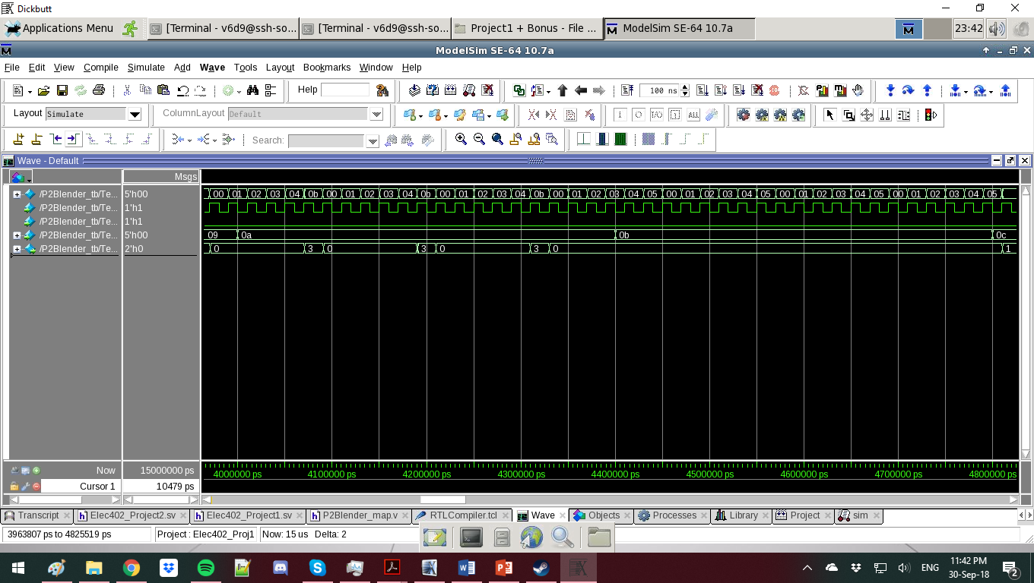

The changing of states for input mode 10, transitions from 06 to 11, which are the high-power states so output is 3



The changing of states for input mode 11, transitions from 06 to 11, which are the high-power states so output is 3, but the duty cycle is 0 in this final mode

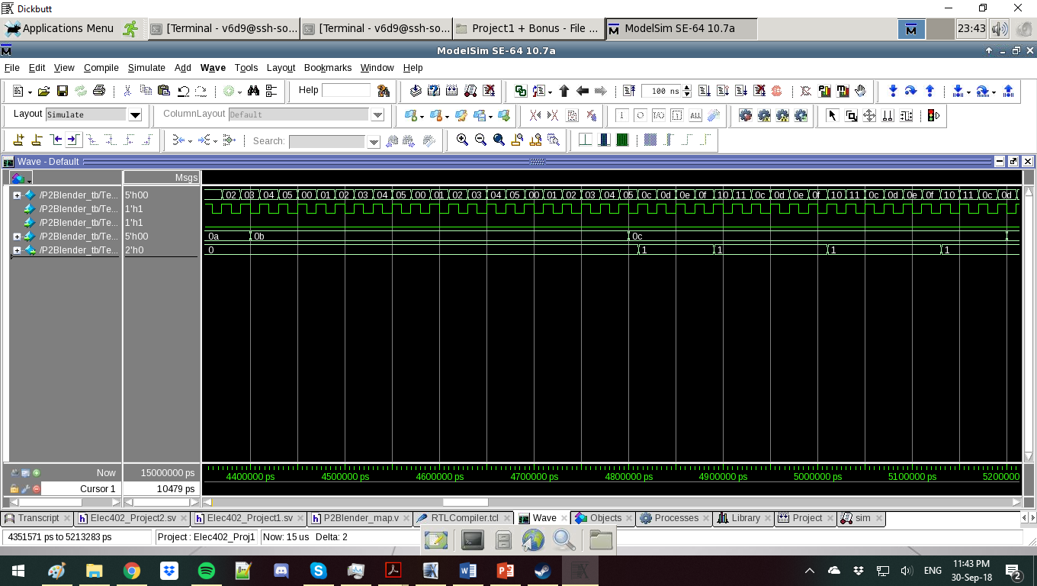

The changing of states for input mode 12, transitions from 12 to 17, which are the low-power states so output is 1

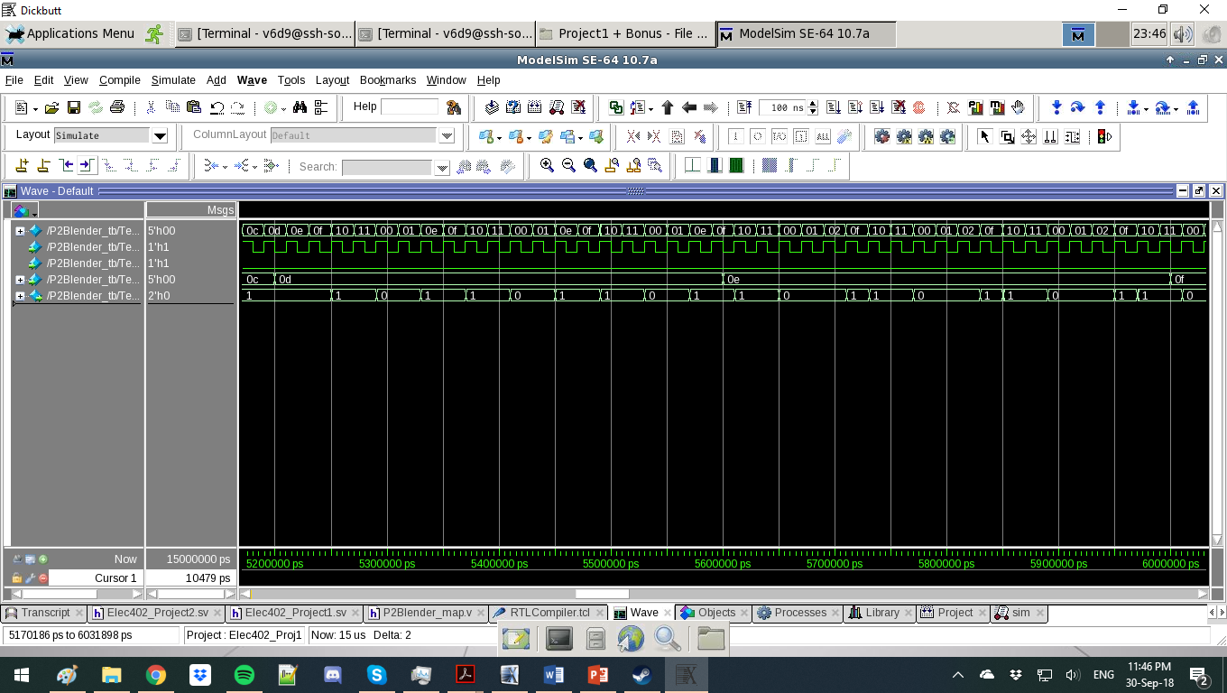

The changing of states for input mode 13, transitions from 12 to 17, which are the low-power states so output is 1



The changing of states for input mode 14, transitions from 12 to 17, which are the low-power states so output is 1

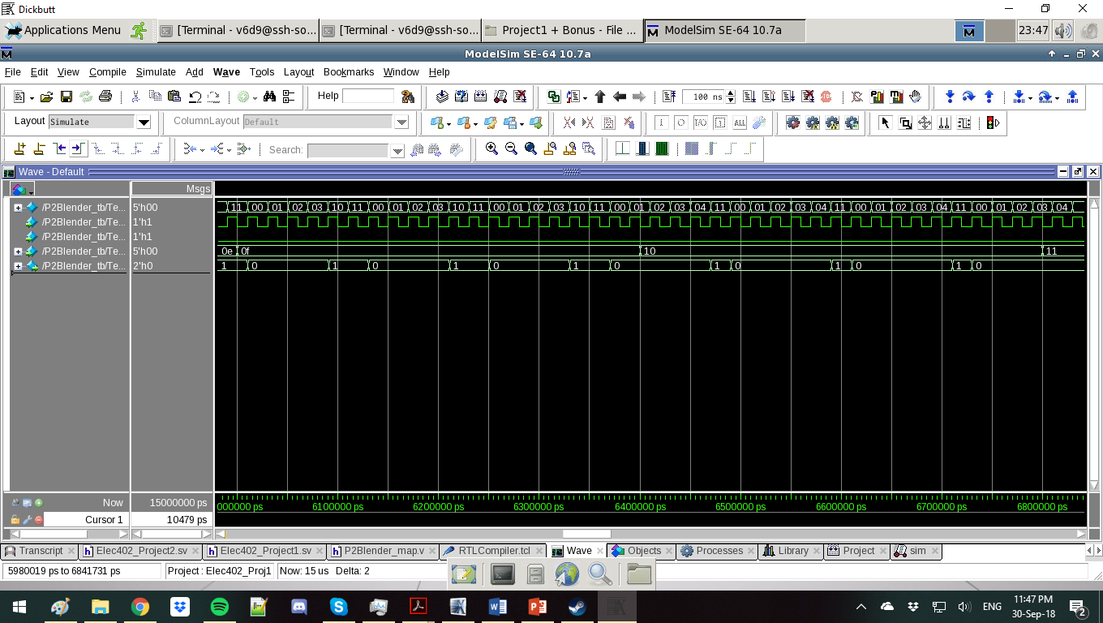

The changing of states for input mode 15, transitions from 12 to 17, which are the low-power states so output is 1



The changing of states for input mode 16, transitions from 12 to 17, which are the low-power states so output is 1

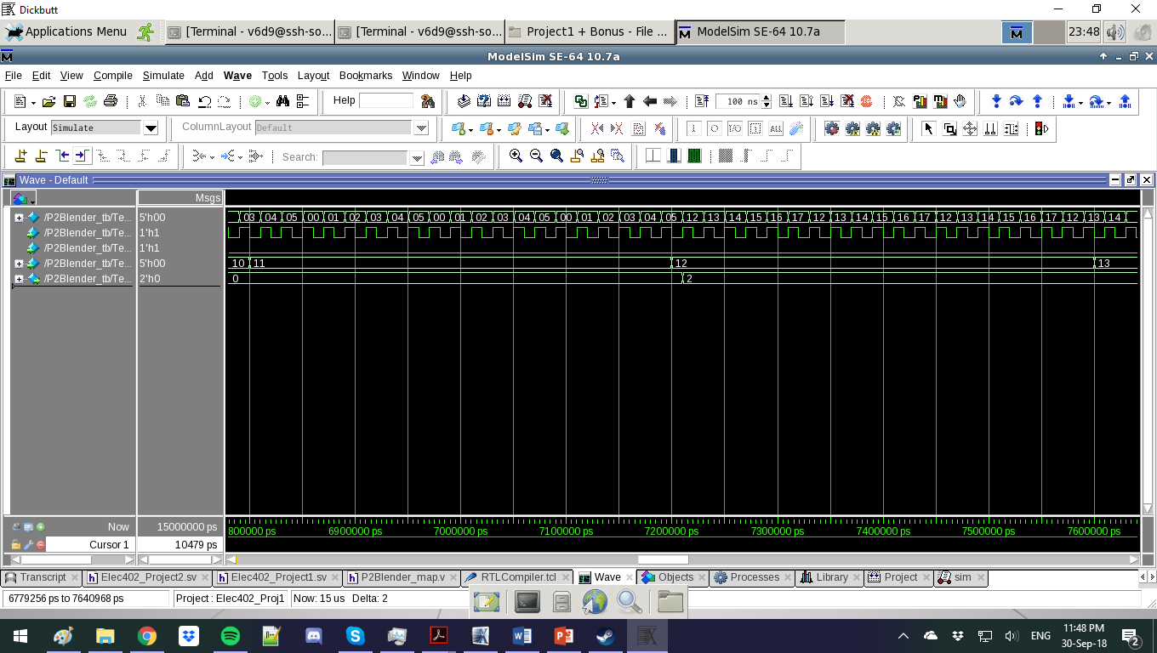

The changing of states for input mode 17, transitions from 12 to 17, which are the low-power states so output is 1. However, the duty cycle is 0, so there is no output.



The changing of states for input mode 18, transitions from 18 to 23, which are the medium-power states so output is 2

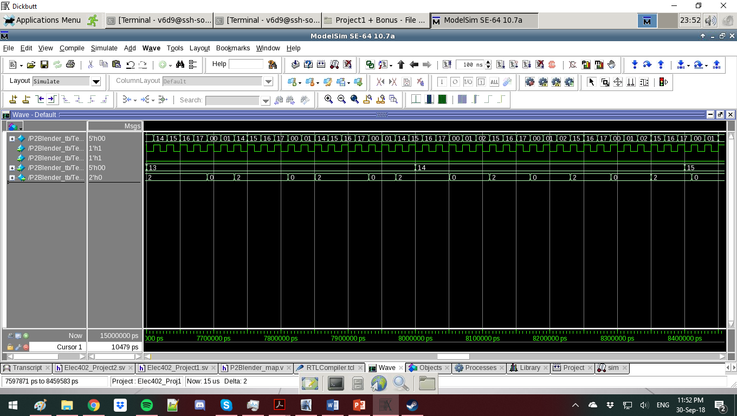

The changing of states for input mode 19, transitions from 18 to 23, which are the medium-power states so output is 2



The changing of states for input mode 20, transitions from 18 to 23, which are the medium-power states so output is 2

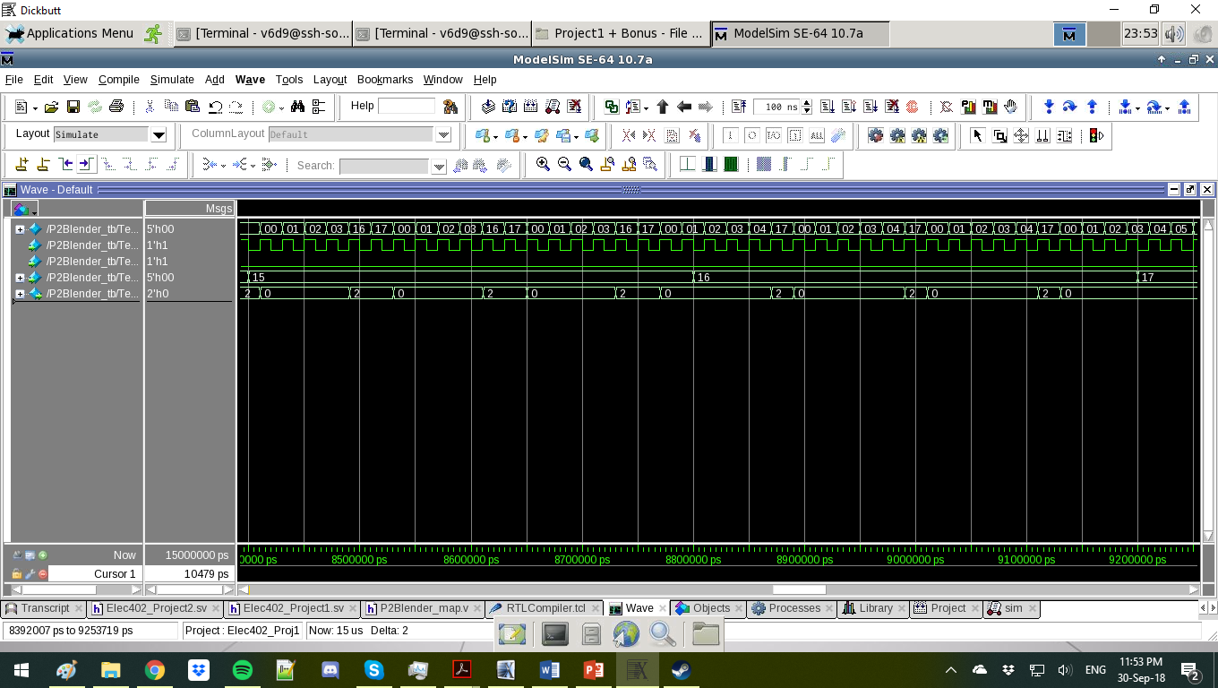

The changing of states for input mode 21, transitions from 18 to 23, which are the medium-power states so output is 2



The changing of states for input mode 22, transitions from 18 to 23, which are the medium-power states so output is 2

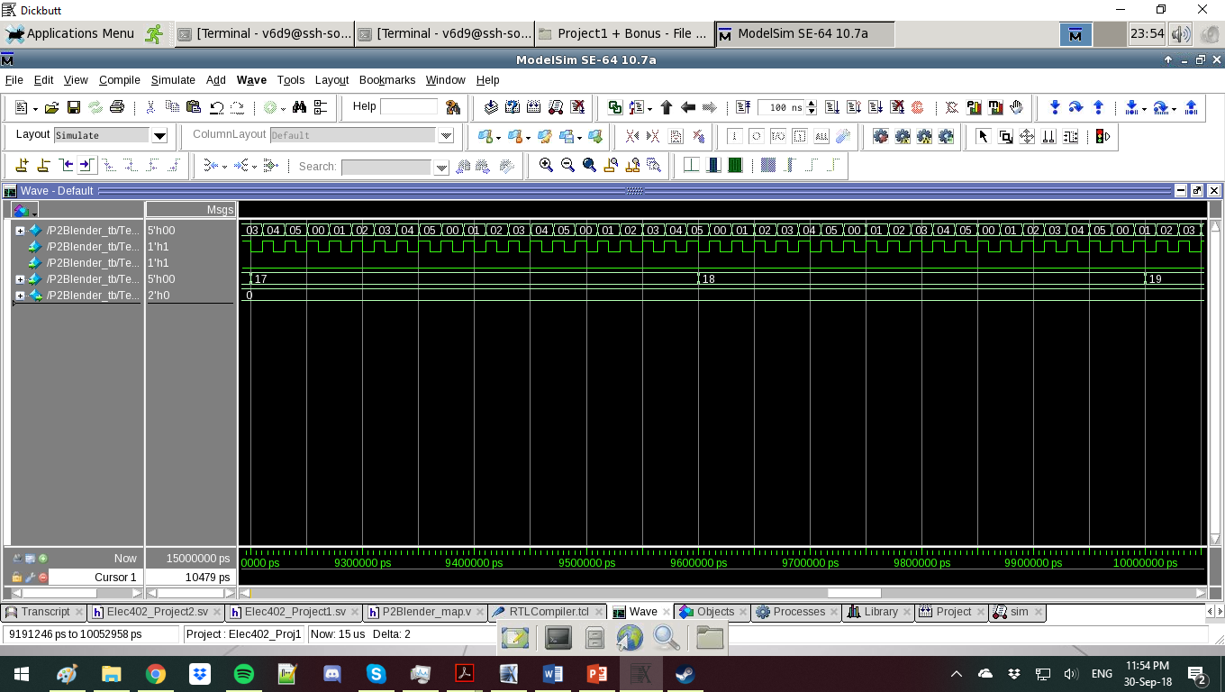

The changing of states for input mode 23, transitions from 18 to 23, which are the medium-power states so output is 2. However, the duty cycle is 0, so there is no output.

The next 5 states have no output assigned to them, as they are empty modes that have no conditions. Because of this, they cycle through the no-power states, 0 to 5.



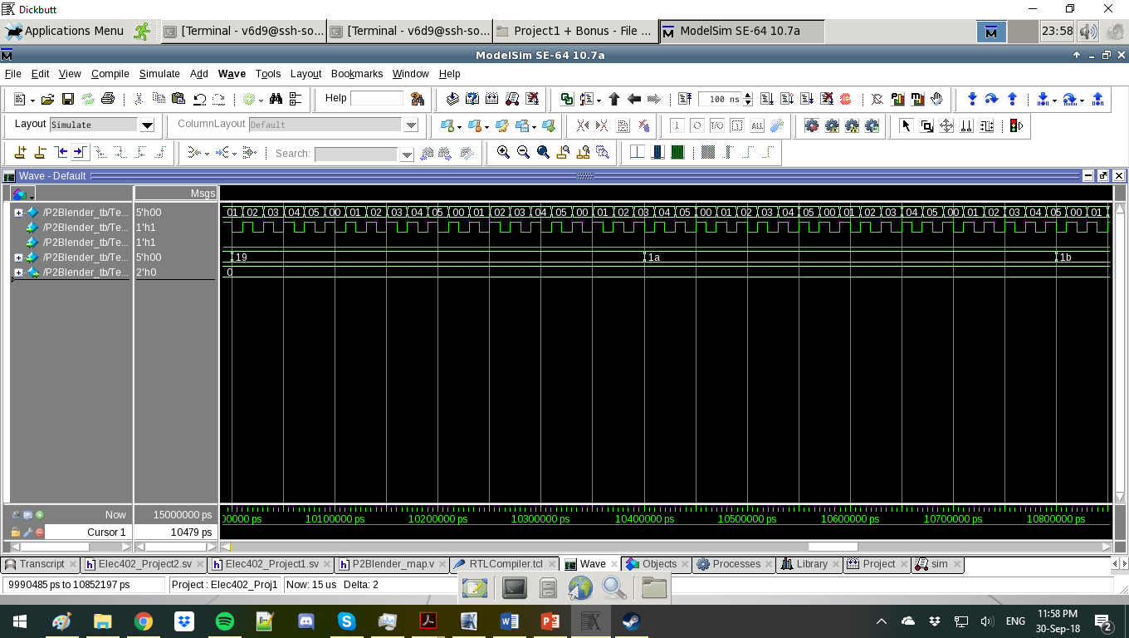 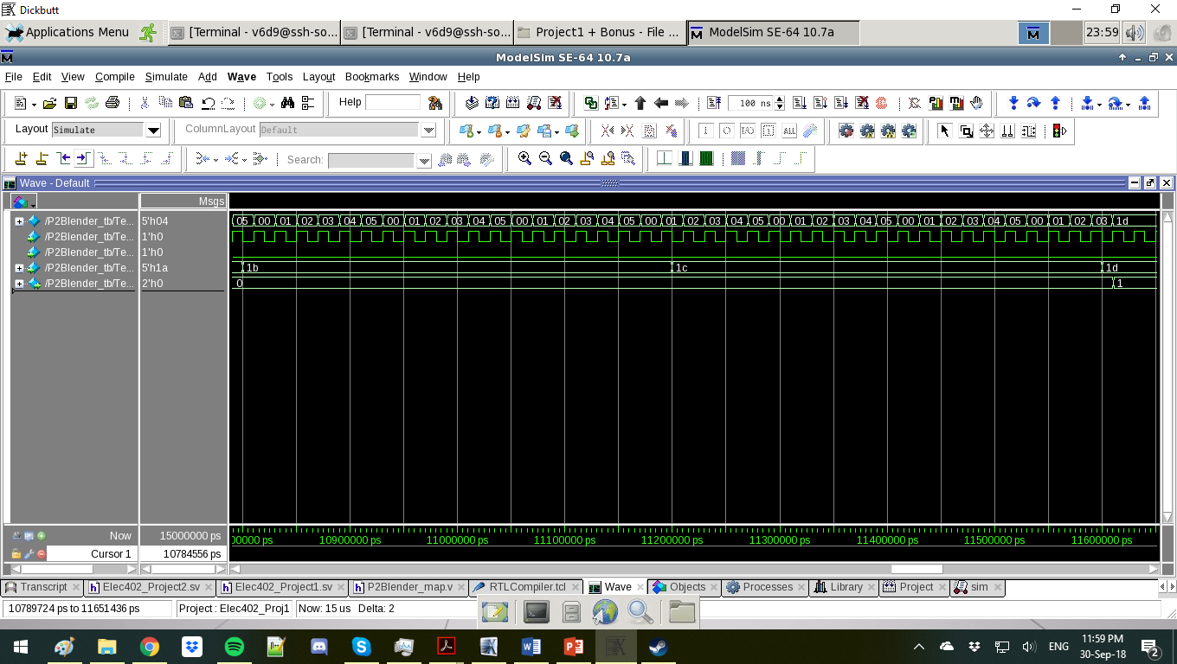

The last 3 states (29, 30 and 31) are all Pulse states, which means for as long as the button is pressed down (shown by the input mode) they will be at Low (29, Output 1), Medium (30, Output 2), or High (31, Output 3)

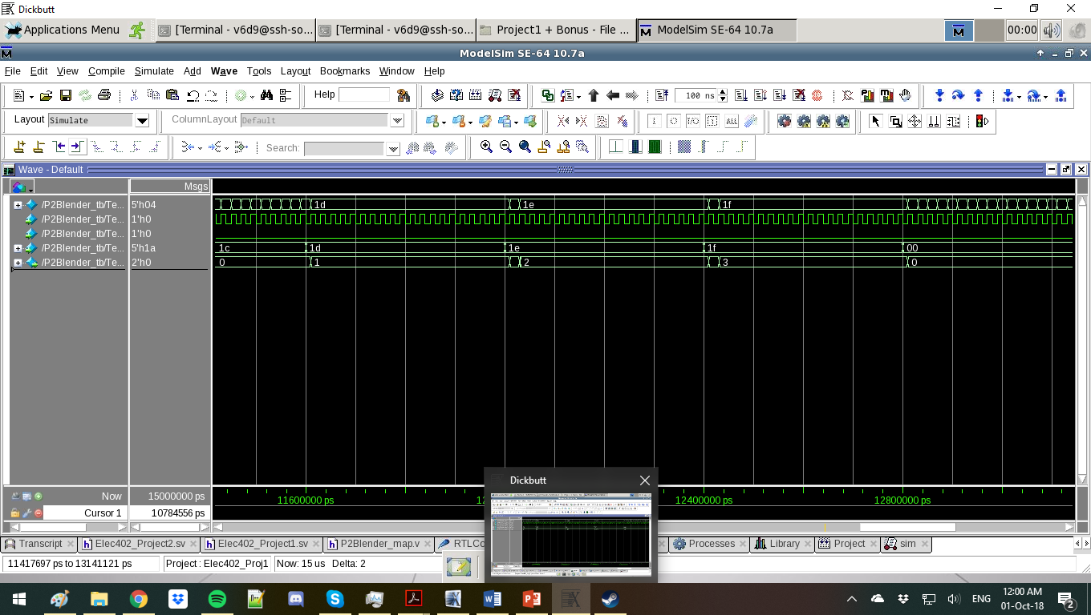  

(The mode input display is in hexidecimal on Modelsim, even if I’ve mentioned the mode input in the report in decimal)

Project 2 differs from Project 1 by doubling the number of states. Although some new calculations have been introduced, fundamentally they are the same project. I have included the .sv files of both the Testbench of Project 2 and the Project 2 itself. The above files were all generated from the Cadence compiled .v file and as can be noted, there are no differences in simulation.

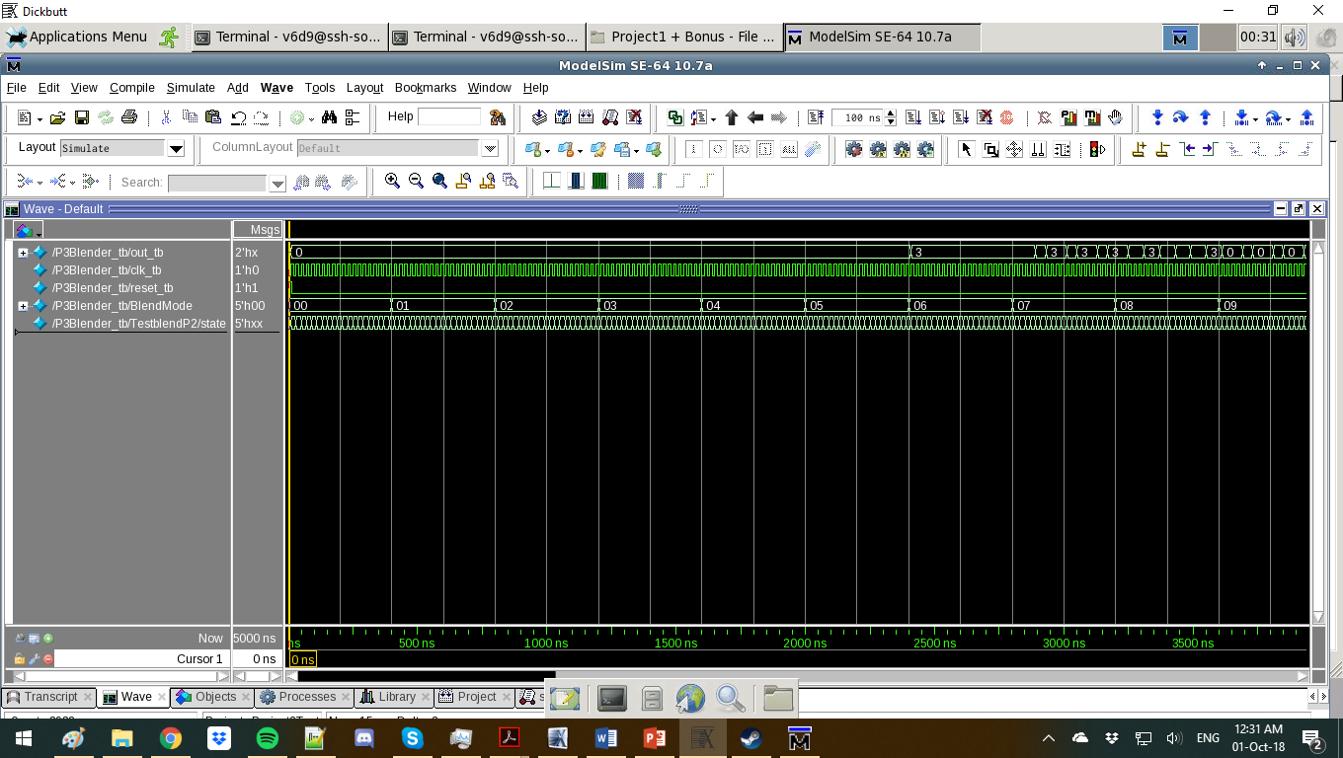



As seen, the conditions are still the same, with the first 6 modes ( 0 to 5 ) having 0 output, and the next few modes having a changing duty cycle for the highest level of output.

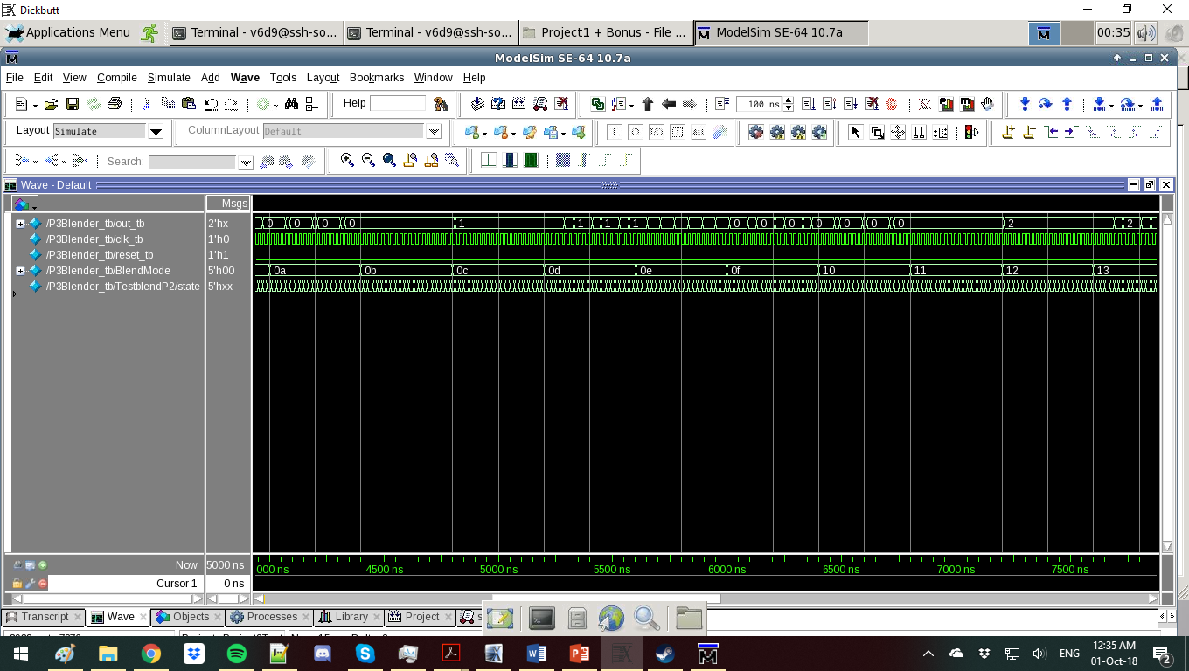 

The next ones are the low-power states with reducing duty cycles, such that input mode 6 would have the highest duty cycle for that level of output, as would 12 and 18.

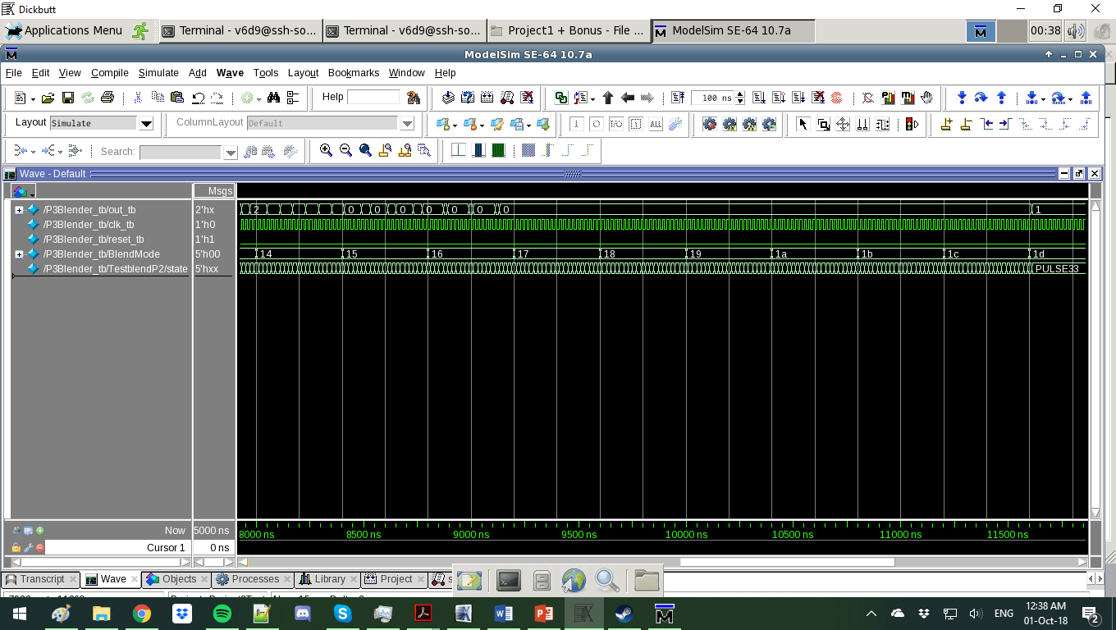 

The blank states (23 – 28) are still the same on both the .sv and the .v files, as can be seen here.

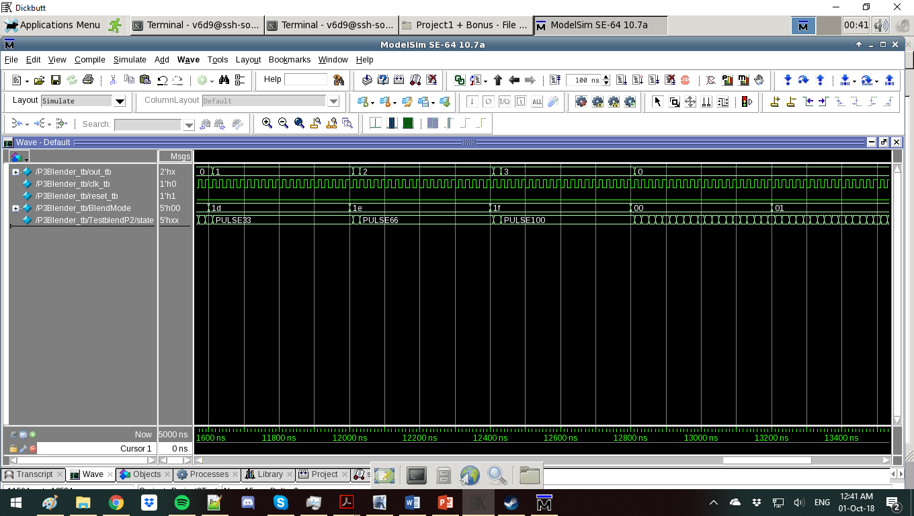

The Pulse states are the same and have identical waveforms.

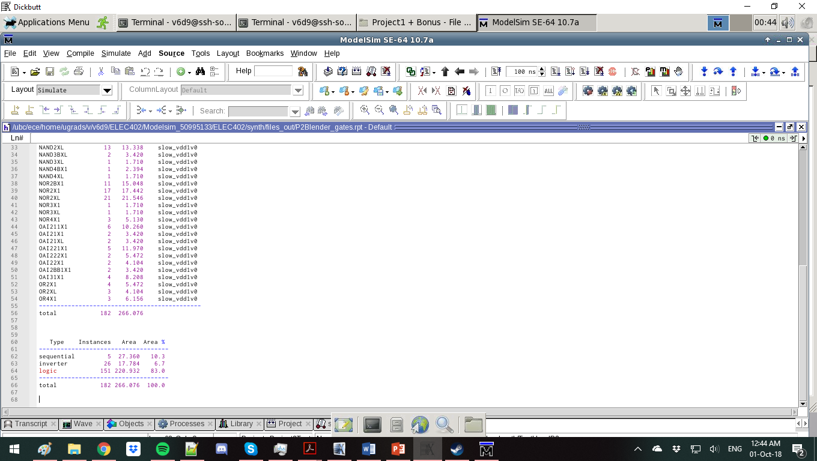

Included is a screenshot of the report.